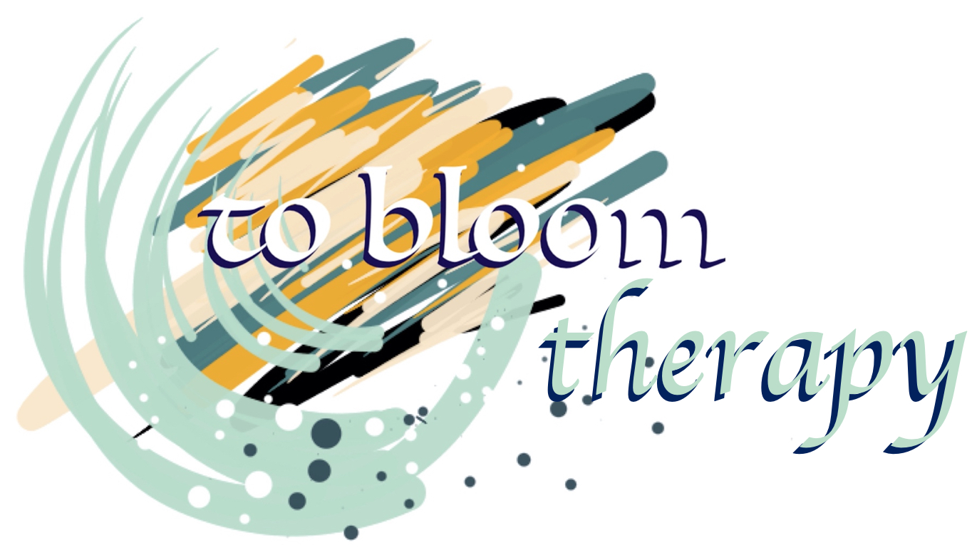
Janet G Havemann Bowser
Art Psychotherapist
B.A Hons Fine Art, M.A Art Therapy
B.A.A.T Member, H.C.P.C Registered
janhavemann@gmail.com
07921180217
www.tobloom.co.uk
How does Art Therapy help?
Art therapy can help improve behaviour, raise achievement, encourage attendance and help pupils take part more fully in school life.
The pupils who may benefit are those:
- In danger of exclusion
- Experiencing emotional and behavioural difficulties
- Those with communication and social difficulties
- Those struggling with particular life events such as bereavement, changes in family structure, and illness
- Who are refugees or are seeking asylum
- Who have suffered abuse, bullying or trauma
- With Autistic Spectrum Disorders
- Children in the Social Care system, CIC, PLAC.
- Children on the SEND register
- Children under Child Protection or Children in Need plans
These pupils may present as withdrawn or anxious, angry, depressed, moody, violent or disaffected. Art Therapy can benefit them individually and have a positive impact on the school environment.
What is Art Therapy?
The basic premise of art therapy is art as a form of expression, this negates the need for words, or talent and emphasises the development of self-expression through the art mediums. A fixed hour a week is spent in either one-on-one time, or a small group. This encourages pupils to engage in communication and create a working relationship aimed at their specific developmental stage. Art Therapy provides a space for the pupils to engage with their emotional world in a safe facilitating environment.
Working closely and intensely with pupils allows the therapist the time to engage with the nuances of their patterns of behaviour, and allows the development of interventions that alleviate some of their anxiety triggers. One of the main areas of focus is the pupil’s behaviour and its effects on relationships, in and outside of school. The knowledge gained through this work was then fed back to the staff and translated into practical ideas and solutions for a healthier classroom environment suited to the specific needs of the individual pupils.
The Process
Consent from the child’s parent or carer will need to be gained, in writing. This document will be provided by the Art Therapist along with a referral form. This referral form will then need to be completed by the SENCO or school representative, with the support of the parent/carer. An initial assessment will then be facilitated by the Art Therapist to ascertain whether Art Therapy is the correct intervention to offer the child, and if the timing is suitable for the particular scenario presented. This will then be discussed with the team around the child and the arrangements will be made to provide therapy sessions based on the agreed outcomes for the therapeutic intervention.

Therapeutic interventions:
There are five areas of intervention that can be offered to the school, these are as follows:
1. Individual therapy. Students will be offered a weekly, one-to-one hour-long session. There will be an initial assessment followed by either a six or twelve-week therapy intervention. Pupils who may benefit are those in danger of exclusion and or experiencing emotional and behavioural difficulties.
2. Group therapy. A group of between four and six students will be offered a weekly hour-long group session. The students will be individually assessed followed by either a six or ten-week therapy program. Pupils who may benefit are those with social and communication difficulties, or those struggling to relate to their peer group.
3. Staff support group. This would be run as an open group whereby staff may access support once a month, or on a termly basis. This may offer the staff group a space to explore some of their feelings in relation to their work and support any concerns they may have.
3. Staff individual therapy. Staff can be offered individual therapy on an ad hoc basis. This can be limited to the school’s well-being insurance budget.
4. Staff workshops. These would be facilitated as and when required based on Psycho-Education and support for staff. The premise for the workshop would be based on the specific needs of the school. The topics may include Attachment Theory and how this relates to the classroom setting, Bereavement support, Self-care or Creativity in the Classroom and Beyond.
5. Trauma debriefing. This would be run on an ad hoc basis, if and when required. This may be useful to deal with trauma such as death or injury, when the pupils and/or staff need additional psychological support.
Fees Structure
All the fees below are inclusive of administration. This includes the acquisition of consent from parents/carers, note writing and professional consultation time with relevant staff. Attendance at TAC/CIN/CP/CIC meetings and Parent consultation meetings will be charged at an hourly rate. Professional report writing is charged per report at £65.
Fee Structure:
Individual
Assessment session | 1.15 hr | £ 97.50
Therapy Session | 1hr | £ 65
Six sessions | 6hrs | £ 390
Twelve sessions | 12hrs | £ 780
Group
Assessment (maximum four clients) | 1.15hr | £ 150
Additional clients @ £12 per client
Therapy session | 1hr | £ 120
Six sessions | 6hrs | £ 720
Ten sessions | 10hrs | £ 1200
Staff Group
Support session | By Quote
Staff Workshop/Inset training
Negotiated topic | By Quote
Trauma debriefing
As required | By Quote
Day Rate
Four/Five individuals or, | £ 350
Two individuals and One group or,
Two Groups.
There may be a mileage charge for locations exceeding a 20-mile radius from Spalding. This is charged at 50p per mile.
Requirements
The school would be required to provide a room that is free from interruption and a secure storage cupboard for the client’s artwork. Preferably the space will include a sink and washable floor. The Art Therapist will provide all the art materials needed to complete the work.
Contact
For more information or a free telephone consultation please contact Janet Havemann Bowser.

mobile: 079 2118 0217
email: janhavemann@gmail.com
www.tobloom.co.uk
BA Fine Arts Hons, MA Art Psychotherapy,
British Association of Art Therapist Full Member,
Health Care Professionals Council Registered.

