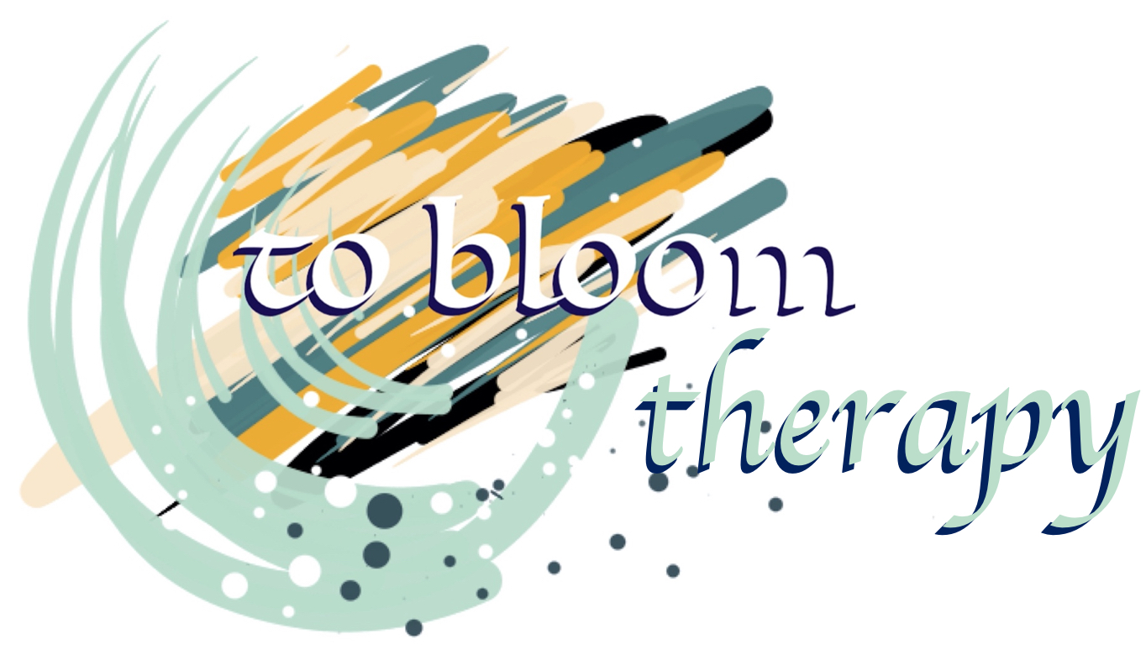
Janet G Havemann Bowser
Art Psychotherapist
B.A Hons Fine Art, M.A Art Therapy
B.A.A.T Member, H.C.P.C Registered
janhavemann@gmail.com
07921180217
www.tobloom.co.uk

Dear Parents/Carers,
We are able to offer your child the opportunity to participate in a program of Art Therapy.

Art Therapy is a form of psychotherapy that uses a mixture of talking and art making. There is no need to be good or talented at art, to make use of Art Therapy. It is not an art class and the aim is not to increase art skills or make finished pieces of art for exhibiting. It provides a space to talk to an Art Therapist about personal problems, artwork and feelings. The aim is to work together with the Art Therapist, using the art created, to think about what is happening for your child, on a personal level. Sometimes, this can be very moving, or even upsetting for a while. The Art Therapists have received extensive training in working with people’s problems and distress.

Once, your child has been seen by one of our Art Therapists for an initial assessment, a period of individual Art Therapy sessions will be negotiated with their setting. Your child will be given the opportunity to participate, but may choose not to do so. Confidentiality is essential and the content of these sessions will not be discussed outside of the care team surrounding your child, unless there are exceptional circumstances where safeguarding concerns are raised.

All artwork created within the sessions will remain the property of your child. On completion of the agreed intervention, your child shall be given the choice to keep or discard their artwork.

In accordance with the new GDPR regulations, please be aware that your child’s name and date of birth will be held on record under strict data protection parameters. If you have had any external agency involvement, this information may also be stored, along with your name and a record of your consent.

Please note that consent can be withdrawn at any time, by yourself or your child. This can be done by contacting us directly, or by contacting the school Safeguarding Officer.

Please sign and return this consent letter to allow your child to participate in a program of Art Therapy. If you have any concerns or questions, please do not hesitate to contact us, at your earliest convenience.

If you consent to art therapy, your child will be assigned to one of three Art Therapists; either Janet Havemann Bowser (BA MA), Keri King (BA PGCE MA), or Joanne Willis (BA PGCE MA), all therapists are registered with the Health Care Professional Council, are full British Association of Art Therapist Members and hold enhanced DBS checks.

Yours sincerely,

Janet Havemann Bowser. Keri King Joanne Willis
mobile: 079 2118 0217 mobile: 07860794652 mobile: 07723396748
email: janhavemann@gmail.com email: keri@artboxtherapy.co.uk email: jow01265@gmail.com
www.tobloom.co.uk. HCPC registered; BAAT full member HCPC registered; BAAT full member
HCPC registered; BAAT full member

Informed consent for Art Therapy assessment and treatment.

I give permission for Janet Havemann Bowser/Keri King/Joanne Willis to see my child for Art Therapy. I have read the accompanying letter and understand its content.
Name of Child: _______________________ Name of Parent/Carer: ______________________
Signature of Parent: ______________________________ Date: _________________________

If you are happy for your child’s work to be used within professional publications, please read and sign the section below.
At times, for the purposes of professional development, Art Therapist’s publish articles online and in professional literature. Your child’s name would not be used and all identifying characteristics would be anonymised. If you do not wish for your child to be referred to, it will not affect their access to therapy in any way.

Informed consent for use of Art Therapy assessment and treatment in professional literature.

I give permission for Janet Havemann Bowser/Keri King /Joanne Willis to make use of my child’s art therapy sessions for the writing of professional literature. I have read the statement above and understand its content.

Name of Child: _______________________ Name of Parent/Carer: ______________________
Signature of Parent: ______________________________ Date: _________________________
Janet Havemann Bowser Keri King
British Association of Art Therapist Full Member, British Association of Art Therapist Full Member,
Health Care Professionals Council Registered. Health Care Professionals Council Registered.

mobile: 079 2118 0217 mobile: 07860794652
email: janhavemann@gmail.com email: keri@artboxtherapy.co.uk

www.tobloom.co.uk.
Joanne Willis
British Association of Art Therapist Full Member,
Health Care Professionals Council Registered
Mobile:07723396748
email: jow01265@gmail.com

